

|  |  |  |  |  |  |  |  |  |
| --- | --- | --- | --- | --- | --- | --- | --- | --- |
|  | | | | | | | | |
|  | | Sprint Report | | | | |  | |
|  |  | | | | | | |  |
|  | | | |  |  | | | |
|  | | | | Book loan management project  By Eugene ETOUNDI II |  | | | |
|  | | | | 26/01/2024  —  SOFTWARE ENGINEERING PROCESSES  —  Supervised by JOSÉ ANTONIO GALLUD LÁZARO |  | | | |
|  | | |  | | |  | | |

Contents

I. Introduction and Objectives of the Project 3

II. Sprint reports 3

A. Sprint 1: Implement the base architecture of a generic software as a service (SaaS) 3

1. Sprint prep meeting: 3

2. Development of the sprint: 4

3. Meeting at the end of the sprint: 7

B. Sprint 2: Users 8

1. Sprint prep meeting: 8

2. Development of the sprint: 9

3. Meeting at the end of the sprint: 10

C. Sprint 3: Project Design 10

1. Sprint prep meeting: 10

2. Development of the sprint: 12

3. Meeting at the end of the sprint: 12

III. Attachments 12

1. Burnup sprint 2 report 12

2. Burnup sprint 3 report 12

3. Sprint 2 Burndown graph 13

4. Velocity ratio 13

# Introduction and Objectives of the Project

As part of the Software Engineering course, I have undertaken the development of a sophisticated Loan Management Web Application. This project addresses the intricate requirements associated with managing loans of books in a seamless and organized manner.

The primary focus of our application is to streamline the processes related to the borrowing and lending of books within a library or similar facility. The system will cater to the needs of both users seeking to borrow books and administrators responsible for overseeing the lending process. By leveraging cutting-edge technologies and following industry best practices, I aim to deliver a robust and scalable solution that meets the highest standards of software engineering.

Key Features:

* User Management: Efficient handling of user registrations, logins.
* Book Catalog: A comprehensive cataloging system that allows administrators to manage books, their availability, and associated details.
* Loan :
  + Create a book
  + Create a loan
  + Return a book
  + Add copy(ies) of a book
  + Remove copy(ies) of a book
  + Search a book and a loan with a key word
  + Notification to every connected user about a new book added
  + Log management
* Improvements on the view.

Through this project, I aim not only to develop a functional loan management system but also to hone our skills as aspiring software engineers, ready to contribute to the technological landscape. I invite you to embark on this journey with me as I explore the intricacies of software engineering in the development of our Loan Management Web Application.

# Sprint reports

## Sprint 1: Implement the base architecture of a generic software as a service (SaaS)

### Sprint prep meeting:

#### With the product owner: objective/user stories/acceptances tests

* Objective:
  + The objective of Sprint 1 is to implement the initial version of user management functionality, focusing on core features that allow basic user interactions.
* User Stories:
  + As a new user, I want to be able to register with a nickname to access the system.
  + As an existing user, I want to log in using my registered nickname.
  + As an administrator, I want to retrieve a list of system users.
  + As an administrator, I want to check if a user is active.
  + As an administrator, I want the ability to delete a user by their nickname.
  + As a developer, I want to perform various queries related to users for system maintenance purposes.
* Acceptance Tests:
  + User Registration:
    - Scenario 1: User successfully registers with a unique nickname.
    - Scenario 2: User registration fails if the nickname is already in use.
  + User Login:
    - Scenario 1: User successfully logs in with a valid nickname.
    - Scenario 2: User login fails with an invalid nickname or password.
  + Retrieve User List:
    - Scenario 1: Administrator successfully retrieves a list of users.
    - Scenario 2: Retrieving the user list fails for unauthorized users.
  + Check User Activity:
    - Scenario 1: Administrator successfully checks if a user is active.
    - Scenario 2: Checking user activity fails for unauthorized users.
  + Delete User:
    - Scenario 1: Administrator successfully deletes a user by nickname.
    - Scenario 2: Deleting a user fails for unauthorized users.

#### From the team: detailed estimated tasks/hours

* User Management Module Setup:
  + Set up the initial structure for the user management module.
  + Estimated Hours: 4
* User Registration and Login Implementation:
  + Implement the functionality for user registration and login.
  + Estimated Hours: 12
* Retrieve User List Implementation:
  + Implement the functionality to retrieve a list of users.
  + Estimated Hours: 8
* Check User Activity Implementation:
  + Implement the functionality to check if a user is active.
  + Estimated Hours: 6
* Delete User Implementation:
  + Implement the functionality to delete a user by nickname.
  + Estimated Hours: 8

### Development of the sprint:

* Testing with Jasmine:
* Test Automation Setup:
* Configured Jasmine as the testing framework for automated testing.
* Set up test suites and specifications to organize test cases.
  + Unit Testing:
* Conducted unit tests for individual components of the user management module.
* Ensured that functions like user registration, login, retrieval, and deletion were tested in isolation.
* Diagram:
  + Class Diagram:

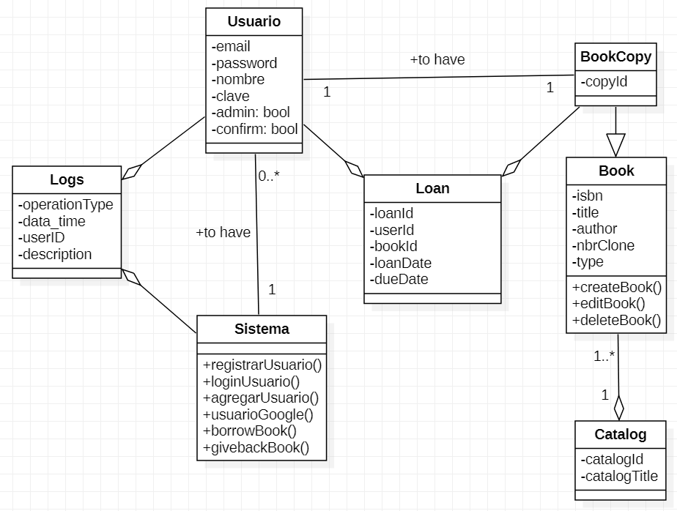

* + Architecture Diagram:

* + Activity Diagram login:

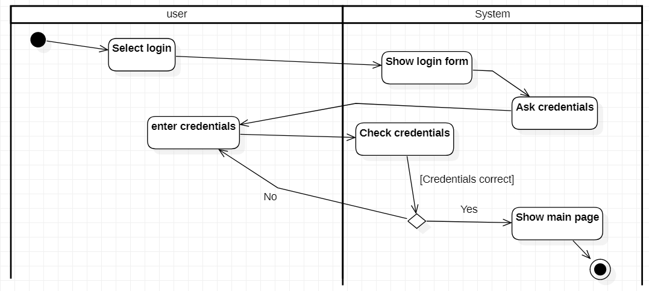

* + Activity Diagram createBook

* + Activity diagram loanBook

### Meeting at the end of the sprint:

#### Review (with the product owner): show the increase.

* Present the functionality allowing users to register with a nickname and log in.
* Highlight any additional features or improvements made based on the teacher's input.
* Demonstrate the ability to retrieve a list of users, check user activity, and delete users.
* Address any questions or concerns raised by the teacher regarding these operations.

#### Retrospective (of the team): sprint burndown is discussed.

* Display the Sprint Burndown chart depicting planned versus actual work completed throughout the sprint.
* Discuss the team's achievements during the sprint, such as completing planned tasks and meeting objectives.

## Sprint 2: Users

1. Sprint prep meeting:
2. **With the product owner: objective/user stories/acceptances tests**

* Objective:
  + The objective of Sprint 2 is to enhance the application's functionality by managing the application state with cookies, implementing third-party authorization (Google), securing data access with MongoDB, and introducing features for user registration, confirmation, encryption, security, and logout.
* User Stories:
  + As a user, I want my application state to be managed efficiently using cookies for a seamless experience.
  + As a user, I want the option to log in using my Google credentials for quick and secure access.
  + As a developer, I want to establish a data access layer with MongoDB for efficient and scalable data storage.
  + As a user, I want a simplified registration process with the option to confirm my account via a confirmation link received by email.
  + As a user, I want my password to be securely encrypted to protect my account information.
  + As a user, I want access to secure routes, ensuring only registered users can use the system.
  + As a user, I want the ability to log out securely to protect my session.
* Acceptance Tests:
  + Application State with cookies:
    - Verify that the application state is managed effectively using cookies.
    - Ensure that users can navigate seamlessly between different sections without loss of data.
  + Third-Party Authorization (Google):
    - Confirm that users can log in using their Google credentials securely.
    - Validate that user information is retrieved and stored appropriately.
  + Data Access Layer with MongoDB:
    - Ensure that MongoDB is integrated into the application for efficient data storage.
    - Verify that data retrieval and manipulation operations work as expected.
  + Local User Registration:
    - Test the local user registration process, including form validation and user creation.
    - Confirm that user details are stored securely in the database.
  + Account Confirmation by Email:
    - Validate that users receive a confirmation email with a link for account verification.
    - Confirm that clicking the verification link successfully activates the user account.
  + Password Encryption:
    - Test the encryption of user passwords to ensure security.
    - Validate that encrypted passwords match the expected format.
  + Secure Routes:
    - Test the implementation of secure routes to prevent unauthorized access.
    - Ensure that only registered users can access protected sections.
  + Logout Functionality:
    - Validate the secure logout functionality.
    - Confirm that users are logged out, and session data is appropriately cleared.

1. **From the team: detailed estimated tasks/hours**

* Manage Application State with Cookies:
  + Implement client-side and server-side logic for managing the application state with cookies.
  + Estimated Hours: 10
* Implement Third-Party Authorization (Google):
  + Integrate Google OAuth for user authentication.
  + Implement the necessary backend and frontend components.
  + Estimated Hours: 16
* Implement Data Access Layer with MongoDB:
  + Set up MongoDB integration, including schema design and CRUD operations.
  + Ensure proper handling of data retrieval and storage.
  + Estimated Hours: 20
* Implement Google One Tap:
  + Integrate Google One Tap for a streamlined authentication experience.
  + Implement frontend components for Google One Tap.
  + Estimated Hours: 12
* Implement Local User Registration:
  + Develop the user registration form and backend logic.
  + Include form validation and error handling.
  + Estimated Hours: 14
* Implement Account Confirmation by Email:
  + Set up email services for sending confirmation emails.
  + Implement backend logic to process confirmation links.
  + Estimated Hours: 18
* Encrypt User Password:
  + Implement password encryption for user security.
  + Ensure that encrypted passwords adhere to security standards. - Estimated Hours: 8

1. Development of the sprint:

* Ensure that the application state is managed effectively using cookies.
* Validate that users can securely log in using their Google credentials.
* Confirm the proper functioning of data access with MongoDB.
* Verify the integration of Google One Tap for streamlined authentication.
* Validate the local user registration process.
* Confirm that users receive and successfully confirm their accounts via email.
* Ensure the secure encryption of user passwords.
* Confirm the implementation of secure routes.
* Validate the logout functionality.

1. Meeting at the end of the sprint:
2. **Review (with the product owner): show the increase**
   * Present the application state management using cookies, emphasizing a seamless user experience.
   * Demonstrate Google OAuth integration for secure and convenient user authentication.
   * Highlight the functionality of the MongoDB data access layer, emphasizing efficiency and scalability.
   * Showcase additional features, including local user registration, account confirmation via email, password encryption, secure routes, and logout.
3. **Retrospective (of the team): sprint burndown is discussed**
   * Evaluate the progress made during the sprint by reviewing the Sprint Burndown chart.
   * Display and analyse the Sprint Burndown chart, comparing planned versus actual progress.
   * Identify any deviations or trends that require attention or improvement.

## Sprint 3: Project Design

1. Sprint prep meeting:
2. **With the product owner: objective/user stories/acceptances tests**

* Objective:
  + The objective of Sprint 3 is to enhance the system's security by implementing secret keys management for sensitive information. Additionally, improvements to the user interface, WebSocket integration for real-time communication, end-to-end testing with Playwright, activity logging, and decoupling the client and server will be addressed.
* User Stories:
  + As a system administrator, I want sensitive information to be managed securely with the implementation of secret keys.
  + As a user, I want an improved user interface with the addition of modal elements for enhanced user experience.
  + As a user, I want real-time updates on system events, such as book additions, through WebSocket integration.
  + As a QA engineer, I want to perform end-to-end testing using Playwright to ensure comprehensive test coverage.
  + As a system administrator, I want to log user actions for auditing and monitoring purposes.
  + As a developer, I want to decouple the client and server components for better maintainability and scalability.
* Acceptance Tests:
  + Secret Keys Management:
    - Verify that sensitive information is appropriately managed with the implementation of secret keys.
    - Ensure that access to sensitive data is restricted and follows best security practices.
  + Improved User Interface:
    - Test the user interface improvements, including the addition of modal elements.
  + WebSocket Integration:
    - Validate real-time communication between the server and clients through WebSocket integration.
    - Test scenarios where clients receive instant notifications, such as book additions.
  + End-to-End Testing with Playwright:
    - Create Playwright scripts to cover end-to-end testing scenarios for critical system functionalities.
    - Ensure that Playwright tests cover a wide range of user interactions and edge cases.
  + Activity Logging:
    - Test the implementation of activity logging to save user actions.
    - Verify that logs capture relevant information for auditing purposes.
  + Decoupling Client and Server:
    - Test the decoupling of client and server components to ensure independence.
    - Confirm that changes on one side do not negatively impact the other.

1. **From the team: detailed estimated tasks/hours**

* Secret Keys Management:
  + Implement a secure mechanism for managing secret keys.
  + Estimated Hours: 12
* User Interface Improvements:
  + Add modal elements to the user interface for additional improvements.
  + Estimated Hours: 8
* WebSocket Integration:
  + Integrate WebSocket communication for real-time updates.
  + Implement server and client components for WebSocket functionality.
  + Estimated Hours: 16
* End-to-End Testing with Playwright:
  + Develop Playwright scripts to cover end-to-end testing scenarios.
  + Execute tests and address any issues identified during testing.
  + Estimated Hours: 20
* Activity Logging Implementation:
  + Implement activity logging to record user actions.
  + Ensure logs contain relevant information for auditing.
  + Estimated Hours: 14
* Decoupling Client and Server:
  + Modify the architecture to achieve decoupling between client and server.
  + Refactor code and update dependencies to support the decoupling.
  + Estimated Hours: 18

1. Development of the sprint:

* Ensure the secure management of sensitive information with secret keys.
* Validate the enhanced user interface with modal elements.
* Verify real-time communication through WebSocket integration.
* Ensure comprehensive end-to-end test coverage using Playwright.
* Validate the implementation of activity logging for user actions.
* Test the decoupling of client and server components.
* Conduct end-to-end testing to ensure the seamless integration of all implemented features.

1. Meeting at the end of the sprint:

**Review**

* Submission and evaluation of the project
* Making a video presentation

# Attachments

1. Burnup sprint 2 report

1. Burnup sprint 3 report

1. Sprint 2 Burndown graph

1. Velocity ratio

